**How Payments work?**

* We start by collecting a payment method.
* We then have to verify that.
* Charge money.
* Manage Payments.
* Process order in our App.

All the payment related things are pretty complex tasks - both from a legal and technical side and therefore typically we outsource them.

**Stripe** is a very popular company offering payment services. It offers a great integration and super easy to use.

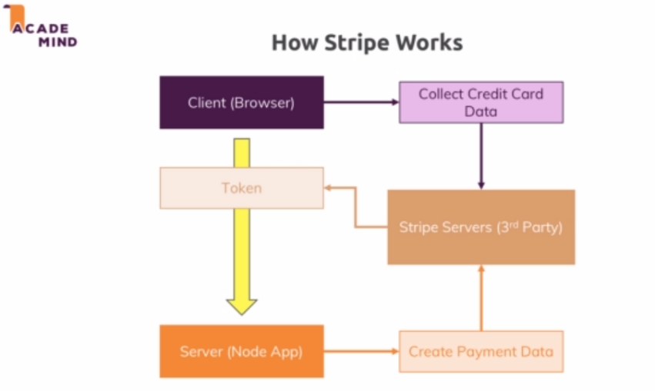

**Using Stripe in our App**

[https://www.udemy.com/course/nodejs-the-complete-guide/learn/lecture/12034728#bookmarks](https://www.udemy.com/course/nodejs-the-complete-guide/learn/lecture/12034728" \l "bookmarks)

**Useful resources:**

Official Stripe.js Docs: [https://stripe.com/docs](https://stripe.com/docs" \t "https://www.udemy.com/course/nodejs-the-complete-guide/learn/lecture/_blank)